## Simulate the transaction logs, see if it errors?

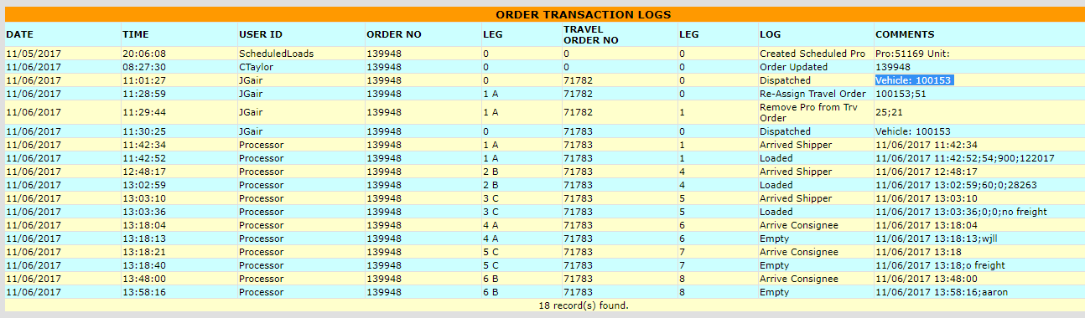

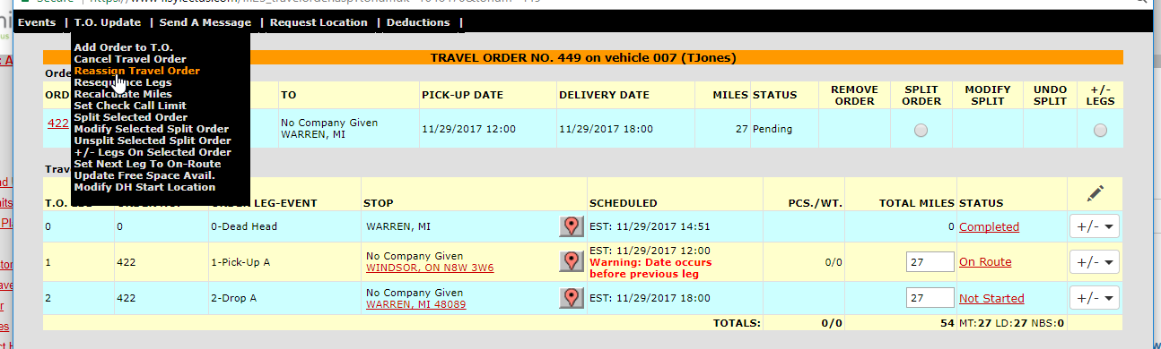

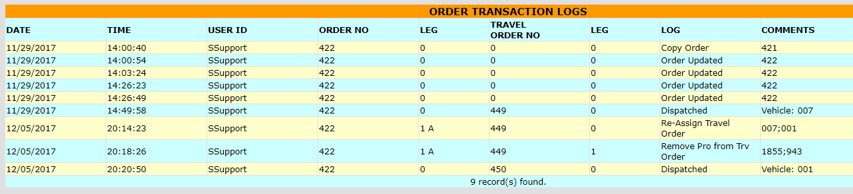

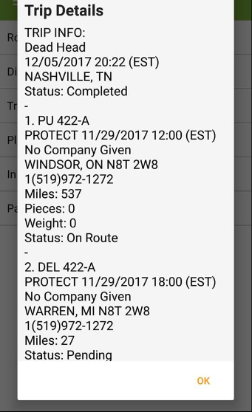

## Swap the driver using the orange truck, seat 1.

New trip details were viewable on the phone.

## Swapped the driver in seat 1 where seat 2 had a phone.

The New trip details remain working on seat 2's phone.

Claw does share their phones. The phone stays attached to the truck in seat 2. As long as seat 1 does NOT have a phone assigned, trip info will be viewable from phone seat 2.

I expired a few drivers on my Test Account and was still avail to swap drivers from the TM.